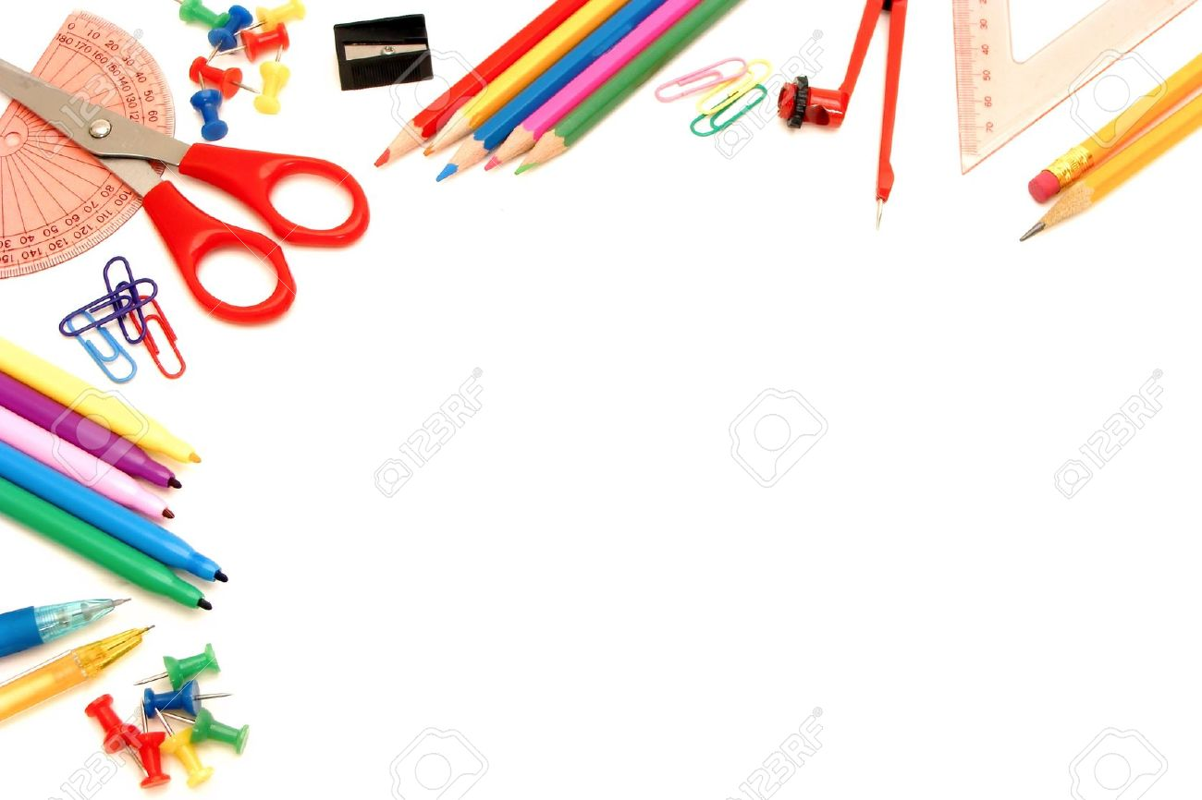

**\*Please put your child’s name on ALL supplies.**

**\*All Teachers will have supply baskets for students.**

**\*REPLACEMENT of supplies during the year is the student’s responsibility.**

**1- Box 1 Gallon Ziploc Bags**

**1- Box Sandwich size Ziploc Bags**

**1- Box Snack size Ziploc Bags**

**4- Boxes of Kleenex**

**2- Pkgs. Individual Kleenex (Pocket Size)**

**2- Rolls of Paper Towels**

**2- Clorox Disinfectant Wipes**

**2- Large Bottles of Hand Sanitizer**

**1- Bottle of Liquid Soap**

**1- Book bag (no wheels)**

**1- Pair of gym shoes (To be left at school.)**

**Face Masks (Disposable or Reusable)**

**Headphones**

**1- Pencil Box**

**2- Boxes of Sharpened No. 2 Pencils**

**2- Colored Pencils 12ct**

**2- Yellow Highlighters**

**4- Large Pink erasers**

**1- Pack of Pencil tip Erasers**

**1- Box of Crayola Crayons 24ct.**

**1- Pack of Crayola Markers**

**1- Colored Pencils**

**2- Pkgs. Expo Dry Erase Markers**

**1- Pair of Scissors**

**12- Glue Sticks**

**2- Small Index Cards (lined)**

**8- Wide rule Spiral Notebooks**

**10- Plastic 2-Pocket folders**

**3- Wide-ruled Loose Leaf Paper**